ServiceNow Integration website  
Setup Information

George Tillett

Sept 22, 2016

## Overview

This website reads information from ServiceNow and displays it in a more friendly view.

All of the functionality it provides can also be done directly in ServiceNow, except for ordering work items in a ranking order. (see below)

## Data Files

Almost all of the information this site displays comes directly from ServiceNow, with these two exceptions.

1. **Common Users file**  
   This file stores a list of the main people on the team.   
   It is only used to pre-populate some dropdown lists.  
     
    ../App_Data/CommonUsers.xml
2. **Work Item Rank file**  
   This file stores a list of work items in a custom order, ranked most important to least important.  
   The work items in the list are displayed in this order on the web site.  
     
    ../App_Data/WorkItemRank.xml

## Special Permissions

The IIS application pool identity needs read/write access to this folder:

C:\ServiceNowIntegration\Add_Data

Give permissions for the folder to this user:

• Domain: SEA-OCIAAPPDV01

• User: IIS AppPool\ServiceNowIntegration (this is the app pool identity)

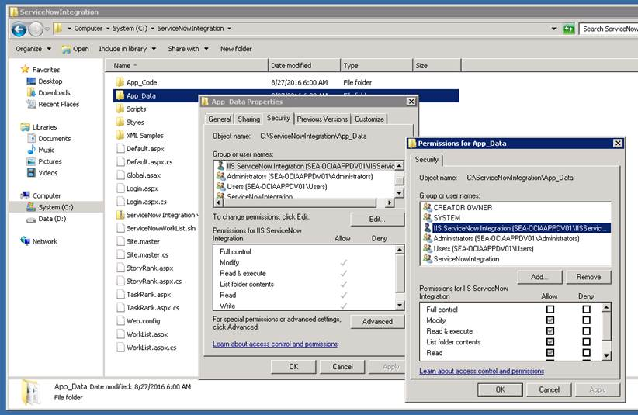

## Application Pool

